PRESS CONTACT:

amazonpublishing-pr@amazon.com

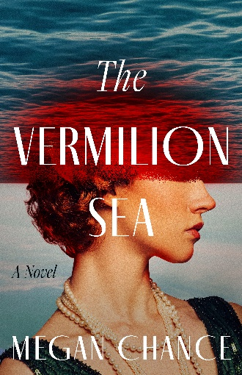
The Vermilion Sea
By Megan Chance | February 3, 2026

From the author of Glamorous Notions comes a harrowing tale set aboard a yacht in the 1920s, where luxury borders on lunacy and mysteries of the deep blur the lines between science and the occult.

The Great War may be over, but brilliant scientist Billie McKennan continues the fight to be taken seriously. When a deliberate omission wins her a marine biologist position aboard an expedition funded by a wealthy eccentric, she quickly discovers she’s not the only one keeping secrets.
The opulent Eurybia sets sail for the Gulf of California with a handful of well-to-do passengers and talented scientists on board. To Billie’s surprise, her ex-husband counts among them. The true mission of the voyage comes into question when a mysterious specimen is captured. And then science unexpectedly gives way to wild rumors and superstition.
Soon, a sinister force takes hold of the vessel—and everyone on it. Billie must reconcile her beliefs with the reality of what she encounters in the vermilion sea. But how much is she willing to sacrifice in order to survive?


About the Author
Megan Chance is the critically acclaimed, award-winning author of more than twenty novels, including Glamorous Notions, A Dangerous Education, A Splendid Ruin, Bone River, and An Inconvenient Wife. She and her husband live in the Pacific Northwest with their two grown daughters nearby. For more information about Megan and her books, please visit www.meganchance.com.

The Vermilion Sea
by Megan Chance
Lake Union| February 3, 2026| 314 pages Trade Paperback Original | ISBN 9781662533501
$4.99 Kindle e-Book | ASIN B0FDLBSR1N
$30.09 Digital Audio | ISBN 9781511379885


|

